Struktur Pemerintahan Desa

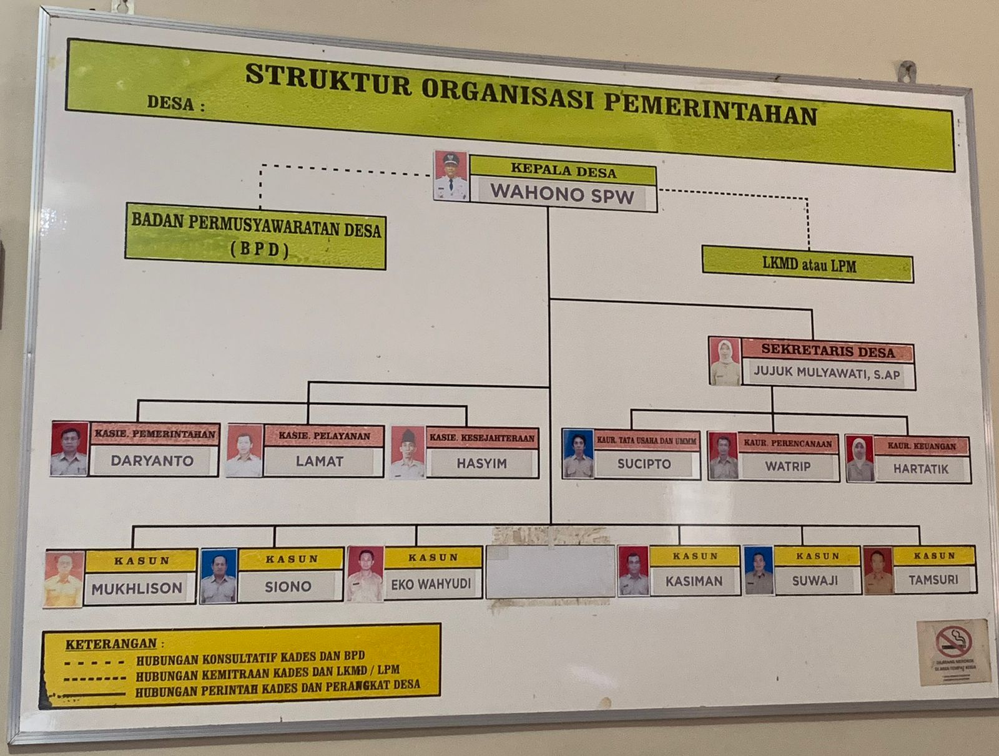

**DATA STAF TAHUN 2017- 2023**

**KEPALA DESA DAYUREJO = WAHONO SPW**

|  |  |  |  |  |
| --- | --- | --- | --- | --- |
| **NO** | **NAMA** | **TAHUN** | **JABATAN/POSISI** | **KETERANGAN** |
| 1 | KOSONG | 2017 |  |  |
| 2 | KIKI PURNAMASARI | 2018 | STAF KAUR UMUM DAN TU |  |
| 3 | ERNAWATI | 2019 |  | PENGGANTI KIKI PURNAMSARI |
| 4 | Jujuk Mulyawati | 2020 | Sekertaris Desa | PENJARINGAN DAN PENYARINGAN PERANGKAT DESA |
| 5 | KHAMIDATUL ULA | 2021 | STAF KASIE KESEJAHTERAAN | OPDES SIKS-NG |
| 6 | WIDIANTI ROSITA | 2021 | STAF KAUR UMUM DAN TU | OPDES E- KIOS PAK LADI |
| 7 | KOSONG | 2022 |  |  |
| 8 | KOSONG | 2023 |  |  |

|  |  |  |  |  |
| --- | --- | --- | --- | --- |
| **DATA PERANGKAT DESA DAN BPD** | | | |  |
| **DESA DAYUREJO** | | | |  |
|  |  |  |  |  |
| **NO** | **NAMA LENGKAP** | **NO. KTP /NIK** | **JABATAN** | **NO. HP** |
|  |
| 1 | Wahono SPW | 3514100603710003 | KEPALA DESA | 085755332769 |  |
| 2 | Jujuk Mulyawati | 3514105211970004 | SEKRETARIS DESA | 085606285681 |  |
| 3 | Sucipto | 3514100602640004 | KAUR UMUM/TU | 0856850634712 |  |
| 4 | Hartatik | 3514105809870005 | KAUR KEUANGAN | 085749033897 |  |
| 5 | Watrip | 3514101312670002 | KAUR PERENCANAAN | 085234644319 |  |
| 6 | Daryanto | 3514101011670002 | KASI PEMERINTAHAN | 081233963479 |  |
| 7 | Hasyim | 3514100503680002 | KASI KESEJAHTERAAN | 085855570009 |  |
| 8 | Lamat | 3514100904680003 | KASI PELAYANAN | 081515076866 |  |
| 9 | Eko Wahyudi | 3514101606760003 | KEPALA DUSUN DAYU | 081234230153 |  |
| 10 | Kasiman | 3514103006640075 | KEPALA DUSUN GUTEAN | 085807205443 |  |
| 11 | Siono | 3514101611660002 | KEPALA DUSUN LEBAKSARI | 085859020599 |  |
| 12 | Mukhlison | 3514100604760004 | KEPALA DUSUN KLATAAN | 081233594565 |  |
| 13 | Suwaji | 3514101407640002 | KEPALA DUSUN TALUNONGKO | 085784667915 |  |
| 14 | Tamsuri | 3514102310750007 | KEPALA DUSUN GAMOH | 082143202756 |  |
| 15 | Khamidatul Ula | 3514104401970002 | Staf Umum | 085708122900 |  |
| 16 | Widianti Rosita | 3514106112980002 | Operator | 085706216146 |  |
| 17 | Bahruddin | 3514100705820009 | Ketua BPD | 085760770447 |  |
| 18 | Suyet | 3514100202840001 | Wakil Ketua BPD | 081236220722 |  |
| 19 | Tinem | 3514105806770002 | Sekretaris BPD | 085259155888 |  |
| 20 | Nasuha | 3514106307890001 | Anggota BPD | 085733463622 |  |
| 21 | Mujiono | 3514100411800005 | Anggota BPD | 085235634933 |  |
| 22 | Harianto | 3514100609820003 | Anggota BPD | 082331786715 |  |
| 23 | Muslimin | 3514102712910001 | Anggota BPD | 085546640638 |  |
| 24 | M. Harnali | 3514101911730001 | Anggota BPD | 0856080138838 |  |
| 25 | Siswanto Miharjo | 3514102711850001 | Anggota BPD | 081334206245 |  |

|  |  |  |  |  |  |  |  |
| --- | --- | --- | --- | --- | --- | --- | --- |
| JUMLAH DATA PERANGKAT DESA DAYUREJO TAHUN 2017 - 2023 | | | | | | | |
| KEPALA DESA DAYUREJO WAHONO SPW | | | | | | | |
|  |  |  |  |  |  |  |  |
|  |  |  |  |  |  |  |  |
| NO | **TAHUN** | **KADES** | **SEKDES** | **KASIE** | **KAUR** | **KASUN** | **STAF** |
| 1 | 2017 | 1 | 0 | 3 | 3 | 6 | 0 |
| 2 | 2018 | 1 | 0 | 3 | 3 | 6 | 1 |
| 3 | 2019 | 1 | 0 | 3 | 3 | 6 | 1 |
| 4 | 2020 | 1 | 1 | 3 | 3 | 6 | 1 |
| 5 | 2021 | 1 | 1 | 3 | 3 | 6 | 2 |
| 6 | 2022 | 1 | 1 | 3 | 3 | 6 | 2 |
| 7 | 2023 | 1 | 1 | 3 | 3 | 6 | 2 |